**NODEMON IN EXPRESS GENERATOR APP**

FIRST WE NEED TO INSTALL NODEMON USING NPM IN OUR EXPRESS GENARATOR NODEJS APP

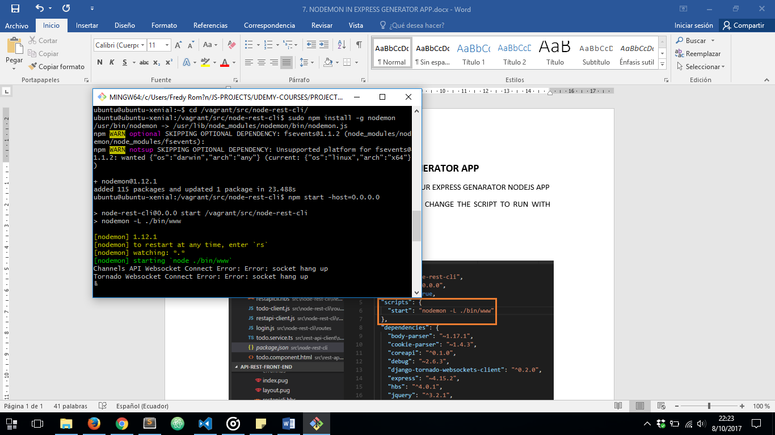

THEN, IN ORDER TO START OUR SERVER WE NEED TO CHANGE THE SCRIPT TO RUN WITH NODEMON OVER VAGRANT BOX:

***package.js*** FILE

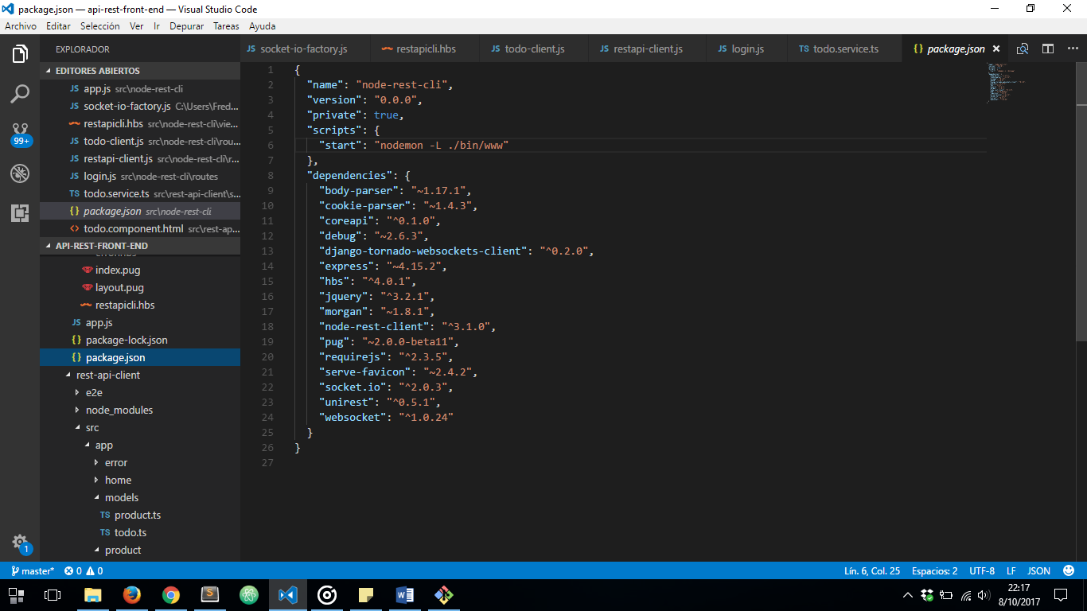

FINNALLY LET’S START OUR SERVER:

